**4.1.3 LOGIN PAGE**

This is the landing page after the home page for the users which are already registered and are working on the system either as an administrator or as a teacher and student. At the time of logging into the system it requires only the username and password kept at the time of sign up.

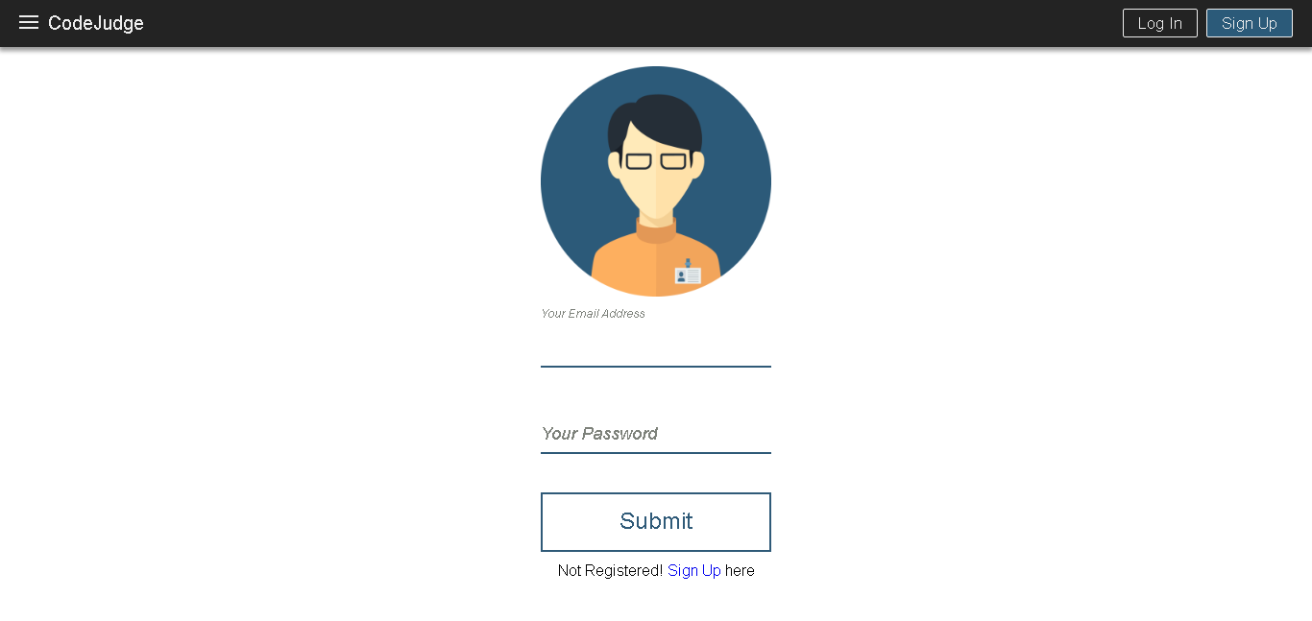Fig. 4.3: Login Page

The login page has automatically turned out to be very compact for the user since during the signup time the fields required are so less that it just needs the above mentioned two fields to verify a user.

A user is logged in only after the details mentioned by him are verified by the system and the user is directed to the page as per his role. After login the landing pages are different according to different roles of the users.

**4.1.4 DIFFERENT LANDING PAGES FOR USERS AFTER LOGIN**

After submitting details on the login page if the user is verified he is directed to the page with respect to his role. This is known as **ROLE BASED ACCESS** methodology which we have used in our project so that every user can perform the task respective to his role without any ambiguity.

**Admin landing page after login**

If the user who has logged in is the administrator of the system then he will be directed to the following page without any skipping any kind of complexity in the system and he can access the privileges which are designed for him during the development of the project. The admin is powered with functionalities of adding teachers and viewing the registered users.

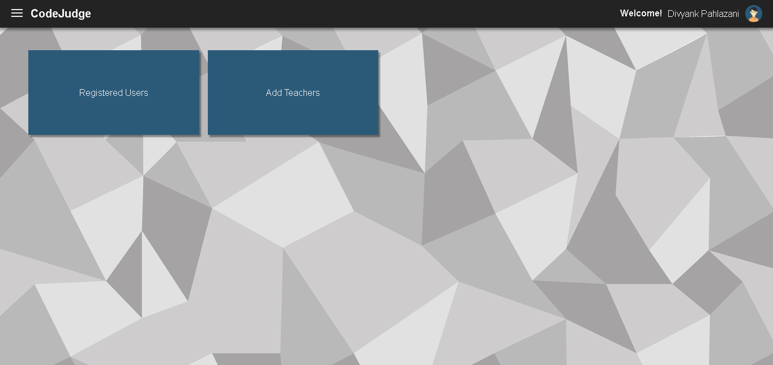Fig. 4.4: Admin Home Page

**Teacher landing page after login**

The teacher has been provided with variety of functionality ranging from publishing practice questions to viewing the result of test. The teacher can publish practice questions, create tests for conducting practical examinations, adding questions in already created tests. Teacher can also modify an already created test before publishing it by changing the question set of the test either by adding new questions or by deleting the previously uploaded questions. Once the test is uploaded the teacher has the liberty to open the test for students whenever he wants to by clicking on enable/disable option.

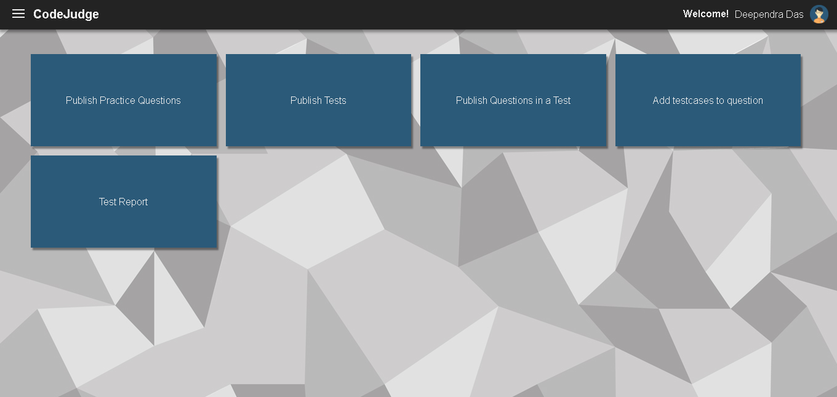Fig. 4.5: Teacher Home Page

The teacher can easily modify or cancel the test whenever he wants to do. Teacher can also perform modifications in the practice set of questions. Last but not the least the teacher can view the result of the test by clicking on view test result and grade the students accordingly.